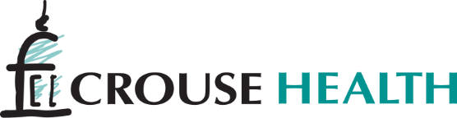
Tuition and Certification Reimbursement Non Union Staff
Maximum of 15 credit hours per calendar year for approved courses in accredited educational programs.
Full-time employees: eligible for reimbursement
Graduate Degree: $500 per credit hour
Undergraduate Degree: $400 per credit hour
Non-credit certification courses (i.e., CASAC Microsoft Certification) 100% of the first $1,000 and 50% of the remaining cost will be paid, up to a maximum of $1,750.

Part-time employees: eligible reimbursement working at least 20 hours per week minimum
Graduate Degree: $400 per credit hour
Undergraduate Degree: $300 per credit hour
Non-credit certification courses (i.e., CASAC Microsoft Certification) 100% of the first $500 and 50% of the remaining cost will be paid, up to a maximum of $1,250.

Part-time employees: eligible reimbursement working less than 20 hours per week
Graduate Degree: $150 per credit hour
Undergraduate Degree: $100 per credit hour
Non-credit certification courses (i.e., CASAC Microsoft Certification) 100% of the first $250 and 50% of the remaining cost will be paid, up to a maximum of $750.

Employees must work one year after the date tuition aid was last granted or the tuition aid must be refunded to the hospital.

NON UNION TUITION AID FOR CROUSE HOSPITAL SCHOOL OF NURSING

Reimbursement is available for employees, their spouses, and any dependent children in the Crouse Pomeroy College of Nursing. Benefits and eligibility are based on the employee's number of years of service on a full- or part-time basis.

Full-time Employees
50% paid tuition for employees employed up to 4 years.
100% paid tuition for employees employed for 4 years or more.

Part-time Employees
50% paid tuition for employees employed 4 to 8 years.
100% paid tuition for employees employed for more than 8 years.
Next Steps: Fill out form # 158 Tuition and Remitted Tuition Application sign it and have your Department Head sign it. Please read the guidelines carefully. Make a copy for your records and forward to Michelle Murphy in Human Resources. If you have questions contact HR at 315-470-…..
Deadlines are below for submission by semester:
Spring Semester Deadline: December 15th
Summer Semester Deadline: May 1st
Fall Semester Deadline: August 15th

