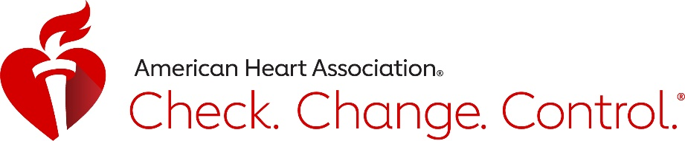

Check It! Challenge social media messages
Please use these social media messages to encourage your employees, organization members, or community audiences to enroll in the Check It! Challenge. If your company or group has a unique code, use your code instead of the CNYBP code. When posting to Instagram, please include the link in your bio, not the post.
Be sure to follow and tag the American Heart Association on all your social media channels. Find us at @AHANewYork on Facebook and Instagram and @HeartCNY on Twitter. The Check It! Challenge hashtag is #CheckIt.
Take pictures of your company leaders getting their blood pressure checked correctly or fun wellness activities at your site to include in your post!

Facebook message 1:
Your blood pressure could be the key to your heart health. Help yourself live a longer, healthier life with @AHANewYork’s #CheckIt Challenge! Learn to check, change, and control your blood pressure. Sign up at www.ccctracker.com with code CNYBP!

Facebook message 2:
Uncontrolled high blood pressure can be deadly, but you can fight back. Join the #CheckIt Challenge with us and @AHANewYork. Learn how to take control of your blood pressure. Sign up at www.ccctracker.com with code CNYBP!

Twitter message 1:
Your blood pressure could be the key to your heart health. Help yourself live a longer, healthier life with @HeartCNY’s #CheckIt Challenge! Learn to check, change, and control your blood pressure. Sign up at www.ccctracker.com with code CNYBP!

Twitter message 2:
Uncontrolled high blood pressure can be deadly, but you can fight back. Join the #CheckIt Challenge with us and @HeartCNY. Learn how to take control of your blood pressure. Sign up at www.ccctracker.com with code CNYBP!

Instagram message 1:
Your blood pressure could be the key to your heart health. Help yourself live a longer, healthier life with @AHANewYork’s #CheckIt Challenge! Learn to check, change, and control your blood pressure. Sign up at the link in our bio with code CNYBP!
Instagram message 2:
Uncontrolled high blood pressure can be deadly, but you can fight back. Join the #CheckIt Challenge with us and @AHANewYork. Learn how to take control of your blood pressure. Sign up at the link in our bio with code CNYBP!

